London Winter LJCC Tournament and Training Day
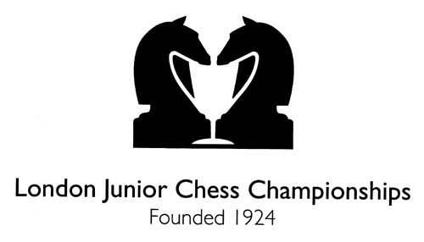

Saturday 2nd December 2018

OPEN TO ALL JUNIORS

Camden School, Sandall Road, London, NW5 2DB

Under 18, Under 12, Under 10, Under 8
and Improver sections

Doors Open 9.30am. Round 1 10am Finish 5pm

This is a graded qualifier for London Junior Chess Championships

Entry
Early bird entry fee £25 before September 16th. Entry fee £25. Late fee £5 after September 30th 2018. On the day entry fee is £35 only if spaces are available as we have limited capacity in the hall.

Round Times
Doors open at 9.30am Please be seated at your board at 9.50am.
Opening Talk to Parents and Players at 9.50am.
10.00am Round One 13.15pm Round Four
11.15am Round Two 14.15pm Round Five
12.15pm Round Three 15.15pm Round Six
16.30pm Prize giving

Round Times Improvers section
Doors open at 9.30am. Please be seated at your board at 9.50am.
10.00am Round One 13.15pm Tactic masterclass
11.15am Opening masterclass 14.15pm Round Three
12.15pm Round Two 15.15pm Endgame masterclass
16.30pm Prize giving

Information
This is a graded chess tournament. Improvers section not graded. Please also note this is not a knockout tournament. All players play in all rounds. Clocks will be used players will have 30 minutes each for all moves. All players will be provided with a certificate. A chess coach will be available to go through games throughout.

There are separate Under 8, Under 10, Under 12 and Under 18 Sections. You must be younger than the section age as at midnight 31st August 2017. These correspond to School Years, i.e. Under 8 is for Year 3 or below, Under 10 for Year 4 or 5, Under 12 for Year 6.

Qualification information
This is a qualifying tournament for the LJCC.

Tournament Information
Parking is available near the venue. We do not provide any supervision of children between rounds so a responsible adult is advised to stay to look after your children. Light refreshments, teas and coffees will be on sale at venue.
All players will receive a certificate. Section winners (1st, 2nd, 3rd and Best Girl) will receive trophies and medals. All results will be submitted to the ECF for grading. Cash prizes for U18 section.
The organisers accept no responsibility for any loss, theft or accident during the event. Adult supervision will only be provided in the playing areas. Organisers will be first aid trained. Parents are responsible for their children during the event, and agree to the terms and conditions in this entry.

Directions
Venue: Camden School for Girls, Sandall Road, London, NW5 2DB.
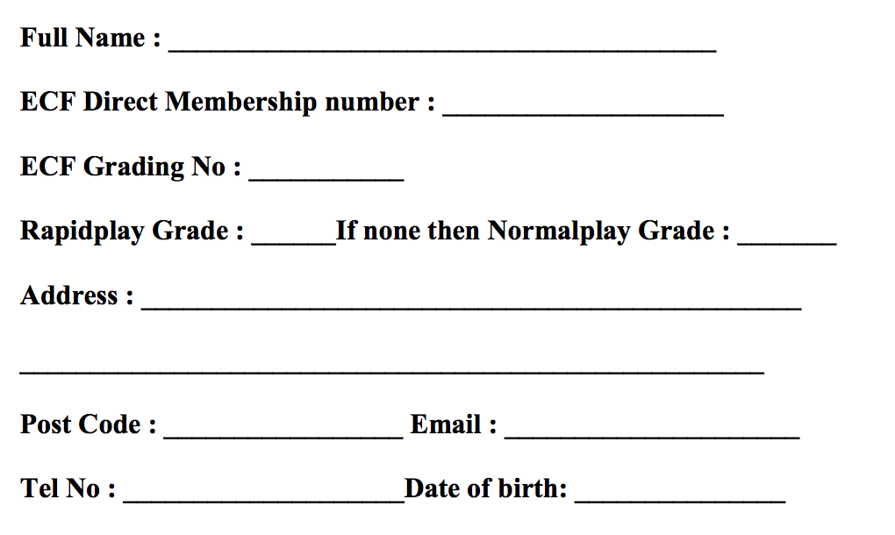
The closest tube station is Camden Town (Northern Line), Kentish Town (Northern Line) which is a 10-15 minute walk from the school.
The closest overground station is Camden Road Station which is a 5 minute walk away from the school.

No parking available at the school. Parking available on the road outside school.

Payment
Payment may be made by bank transfer using
Account number: 1625-9468 and Sort Code: 30-18-98

If using this method then quote your child’s name and section in the subject title and email Lateefah Messam-Sparks (info@chesssparks.com) with entry form information to confirm payment has been made. If you would like an alternative payment method please email or call Lateefah.

Contact
Tournament Organiser: Lateefah Messam-Sparks
Email: chesssparks@gmail.com
Phone number: 07715 461347




